# ORIGINAL ARTICLE

# Adrenal insufficiency associated with advanced HIV may explain the high mortality.

## TRP Mofokeng1, A Grossman3, RS Millar5, TS Pillay6, J Sempa7, J Singbo, J Dave2, NS Levitt2, R Erasmus2, PJ Raubenheimer2, C Dandara2, G Johansson4, IL Ross2

1Division of Endocrinology, Department of Medicine University of the Free State, South Africa 2Division of Endocrinology, Department of Medicine University of Cape Town, South Africa 3Department of Endocrinology, St Bartholomew’s Hospital, London, UK

4Department of Endocrinology, Sahlgrenska Academy, Sahlgrenska University Hospital and Institute

of Medicine, University of Gothenburg, Gothenburg, Sweden

5Department of Immunology, Faculty of Health Sciences, University of Pretoria, Private Bag X323, Pretoria 0031, South Africa

6Department of Chemical Pathology and National health Laboratory Servi Tshwane Academic Division, Faculty of Health Sciences, University of Pretoria, South Africa

7Department of Statistics University of the Free State, South Africa

Correspondence should be addressed to: Dr Thabiso RP Mofokeng,

Division of Endocrinology,

Department of Medicine (University of the Free State) South Africa,

e-mail: mofokengtrp@ufs.ac.za

### Abstract:

**Background:**

Sub-Saharan Africa is burdened by a vast HIV-positive population, at risk of life-threatening AIDS defining illnesses and disseminated opportunistic infections, which have been associated with both primary (PAI) and secondary adrenal insufficiency (SAI). We hypothesized that adrenal insufficiency (AI) may partially account for the high mortality in advanced HIV.

### Materials & Methods:

We undertook a prospective case-finding study of HIV-positive patients presenting with advanced disease who were 18 years or older, with a CD4 count of less than 100 cells/ mm3, and a coexistent opportunistic infection. Exclusion criteria were use of oral, intravenous, topical or inhaled steroids in the previous 3 months. A tetracosactide test was performed in patients with a morning random cortisol concentrations of less than 500 nmol/L.

### Results:

A total of 559 patients were recruited, of these, 549 complete records were evaluated. The median interquartile range (IQR) age of patients at enrolment was 36.0 years (IQR: 31.0-43.0). The majority were Black Africans 75.7% and mixed race (22.9%), whites and Asians in (1.2%) and (0.3%), respectively. Of the 549 patients 33 (6.01%) had AI, of whom 24 (72.72%) had (SAI) whereas 9 (27.27%) had (PAI). Overall, 151 tetracosactide tests were performed identifying 27 AI patients, 6 more patients were presumed AI by random cortisol less than 200 nmol/L. Extra Pulmonary tuberculosis (EPTB) and *Cryptococcus neoformans* predominate in the AI group 33.3% vs 19.0%, *p*=0.045, 30.3% vs 3.8%, *p*<0.001, whereas pulmonary tuberculosis (PTB) predominates in the group without AI 42.4% vs 64.7%, *p*=0.01. The diastolic blood pressure was higher in AI versus Non-AI group 73.0 (66.4,80.8) versus 70.0 (60.0, 79.0); *p*=0.012. Fluconazole (33% versus 12.1%) and opiate use (36.4% versus 21.9%) were higher in the AI versus Non-AI group; *p*=0.002 and *p*=0.054, respectively. Duration of illness was longer in the SAI versus the PAI group: 14 days (IQR:14.0, 27.8) versus 10 days (IQR: 7.0, 14.0); *p*=0.006. The overall one-year mortality for the whole cohort was 27.5%. Although mortality was not different in the AI vs non-AI groups, it was higher in patients with AI patients and *Cryptococcus neoformans* 45.5% versus 4.3%; *p*<0.001. Regression analysis revealed that a 50 nmol/L cortisol increase, and 100 pg/L increase in the plasma ACTH was associated with a 11% and 97% increase in the odds of mortality (OR = 1.11, (95%CI: 1.05, 1.18), *p*<0.001) and (OR = 1.97, (95%CI:1.15, 3.59), *p<*0.019), respectively.

### Conclusion:

### AI does not account for the high mortality in advanced HIV even though its mortality rate is marginally higher than that in patients without AI. EPTB and Cryptococcus were predominant OI’s in AI, whereas PTB was the predominant OI in the non-AI group. Increased cortisol and ACTH Concentrations were associated with increased mortality risk.

PTB – pulmonary tuberculosis, EPTB – Extrapulmonary tuberculosis

### Introduction:

Adrenal insufficiency (AI) resulting from deficiency of glucocorticoids and mineralocorticoids is an invariably fatal medical condition without replacement. Prior to the availability of glucocorticoids, most patients with primary adrenal insufficiency (PAI) died within 2 years of diagnosis (1).

Autoimmune adrenal insufficiency predominates in European populations (2), and also in South Africa (3), despite the high background prevalence of tuberculosis (TB) (4). Our recent survey suggests that TB (34%) and Acquired Immune Deficiency Syndrome (AIDS) (29.8%) predispose to the development of PAI (5).

The background prevalence of Human Immunodeficiency Virus (HIV) in sub-Saharan Africa is 9% (6)((7). The mortality in HIV positive patients is higher in resource limited settings for example, sub-Saharan Africa, (8) due to late presentation and inadequate health resources. Patients with HIV may develop PAI due to *inter alia* TB, *Mycobacterium avium Intracellulare* (MAI), cytomegalovirus (CMV), toxoplasmosis, *Pneumocystis carinii*, histoplasmosis and malignancies for example, non-Hodgkin’s lymphoma and Kaposi sarcoma (KS). Additionally, fungal infections including cryptococcus, blastomycosis, and histoplasmosis and medications for example, ketoconazole and mitotane may precipitate PAI (9). Secondary adrenal insufficiency (SAI) may also be caused by *inter alia* TB, toxoplasmosis and CMV in HIV infection (10-12).

There are varied results describing the incidence of hypoadrenalism in patients with HIV. In a study in Pakistan of 64 HIV infected, predominantly male patients (84.9%), Afreen *et al*, reported the AI incidence of 9 (14.0%), using the 250 microgram intravenous tetracosactide test and a 60 minute cortisol concentration of less than 18 microgram/dL (500 nmol/L) (13), whereas in a Nigerian study of 43 newly diagnosed HIV positive patients who were antiretroviral treatment naïve, the AI incidence was 34.8%, using a 1 microgram tetracosactide test (14) and a 30 minute cortisol of less than 500 nmol/L. In India, Sharma et al reported the AI incidence of 24.23 % on HIV positive patients using the cortisol cutoff of 500 nmol/L following a 250 μg tetracosactide test.

Despite optimal replacement therapy in AI in general, patients demonstrate poorer survival due in part to cardiovascular, malignant and infectious diseases, compared to background populations (10, 15). Both overtreatment and insufficient replacement with glucocorticoids during infections and stress-related events confer an increased mortality (16).

We hypothesized that coexistent AI among patients with advanced HIV may accelerate mortality. Our objectives were to determine the incidence of AI among ill, hospitalized HIV-infected patients. In addition, we wished to explore the positive predictive clinical and biochemical characteristics for AI, and the predictors for survival.

### Materials and methods:

Approval to conduct the study (HREC 163/2015) was obtained from the University of Cape Town Faculty of Health Sciences, Human Research and Ethics Committee, which endorses the latest i declaration of Helsinki from 2013. We undertook a prospective case-finding study of HIV positive patients, presenting with advanced disease and an opportunistic infection (OI) to an acute tertiary care medical ward. All participants provided written informed consent. If participants were affected by delirium our research and ethics committee endorsed retrospective informed consent, with a view to limiting bias and providing an equal opportunity for life-saving treatment.

***Inclusion and exclusion criteria***

Inclusion criteria were age 18 years and older, and a CD4 count of 100 cells per mm3 or fewer and an opportunistic infection. The use of oral, topical or inhaled steroids in the previous 3 months represented an exclusion criterion.

***Data extraction***

Patients who met the inclusion criteria had blood samples taken for random serum cortisol and plasma ACTH between 08:00 and 09:00 on the day of enrolment analyzed at a private accredited laboratory. Demographic and clinical data were obtained from history and physical examination. Records of routine biochemistry, haematology and microbiology were extracted from the National Health Laboratory Service (NHLS) repository. Where the random serum cortisol was less than 500 nmol/L, a short 250 µg intravenous tetracosactide stimulation test was performed, usually on the following day.

***Biochemical measures of plasma ACTH and serum cortisol***

Due to the unavailability of the gold standard LC/MS cortisol diagnostic test (17) we utilised the Roche COBAS ECLIA tests to measure both cortisol and ACTH concentrations. For the random plasma ACTH, the specimen was collected in EDTA vials on ice and for serum cortisol concentration, clotted blood was submitted.

***Methodology for serum Cortisol and ACTH***

Serum cortisol concentrations were assayed on the Roche Cobas 6000 e601 platform, using the Elecsys Cortisol II antibody. Serum cortisol concentrations were determined using Electro luminescence assay (ECLIA). This method has been standardized against the institute for reference materials and measurements in brackets (IRMM)/IFCC-45 panel. The measuring range is 1.5 nmol/L to 1750 nmol/L with a limit of detection (LOD) of 1.5 nmol/L (18).

***The tetracosactide test***

The samples of plasma ACTH collected in Ethylenediaminetetraacetic acid (EDTA) tubes on ice and serum cortisol obtained during the test were submitted to the National Health Laboratory Services (NHLS). Venous blood was taken at 0 minutes for serum cortisol, followed by 250 µg of intravenously administered tetracosactide and a 30-minute serum cortisol was taken at the conclusion of the test. AI was diagnosed if a 30-minute serum cortisol was less than 500 nmol/L. In patients with confirmed cortisol deficiency, a concomitant plasma ACTH above the upper limit of the reference range (67.7 pg/mL) was consistent with PAI (17), while a low or normal plasma ACTH was diagnostic of SAI (18). Serum cortisol analyses performed to evaluate the diagnostic sensitivity and specificity of stimulated cortisol concentration using cut-offs at 400 nmol/L, and 340 nmol/ L, respectively.

***Determination of survival***

Telephonic follow-up was performed to determine after discharge survival from hospital, through direct patient or family contact. A hospital database (Clinicom®) also corroborated survival, by their attendance at various clinics in the drainage area of our tertiary hospital facility.

### Statistical analysis:

Statistical analyses were performed using R-programing software *(*ref: R Core Team (2023*). _R: A Language and Environment for Statistical Computing_. R Foundation for Statistical Computing, Vienna, Austria. https://*[*www.R-project.org/)*.](http://www.R-project.org/).) Categorical variables were presented as frequencies and percentages, and continuous variables were expressed as medians and were compared using the Wilcoxon-Mann-Whitney test. Proportions and categorical variables were compared, using Pearson’s chi- square test or Fisher’s exact test as appropriate. We ranked CD4 counts into tertiles of 0-33; 34-66 and 67-100, respectively to determine if AI was associated. Univariate Cox-Proportional Hazard regression was used to estimate the of each variable on mortality. Multivariable Cox-Proportional Hazard regression analysis was used to identify independent predictors of survival. The significance level was set at *p* <0.005. For analysis of survival data, we described those who were discharged from the hospital and evaluated within 3 months (early survivors), followed by 6 months (intermediate survivors), and 12 months follow- up (late survivors).

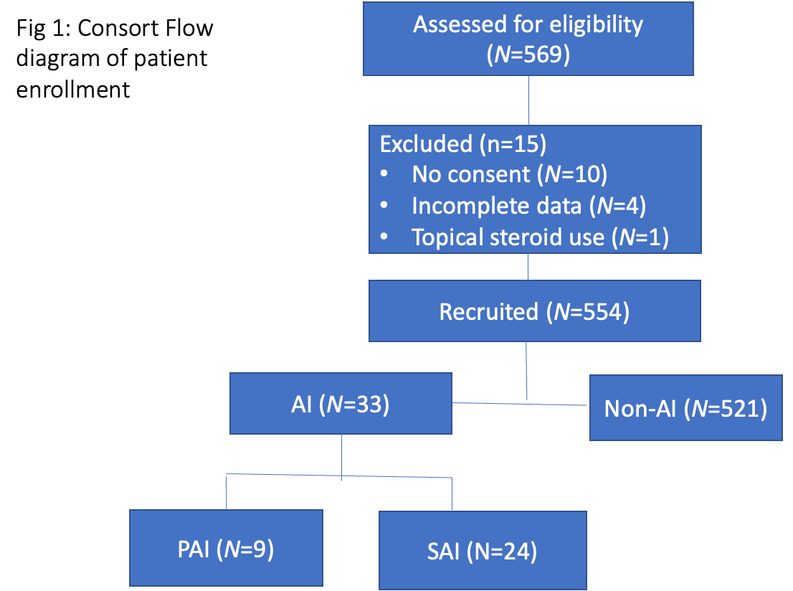

### Results:

A total of 559 patients were recruited, of whom 10 withdrew from participation and 549 participants were included in the final analysis. Most of the patients were female 280 (51.1%) and the predominant opportunistic infection was tuberculosis in 461 (84%), followed by pneumonia 62 (11.3%), candida 34 (6.2%), and cryptococcus infection in 30 (5.5%). The median, interquartile range (IQR) age at enrollment was 36 years (31.5-43.0) years and when subdivided by CD4 count, patients were significantly younger in the lowest CD4 tertile, 35 years (30.5-42.0); *p*=0.008, compared to the remaining tertiles Table 1.

The distribution of gender and ethnicity did not differ by CD4 distribution. The duration of illness was longer in the highest CD4 tertile; *p*=0.036 compared with the remaining tertiles. As expected, the participants with the lowest CD4 count, had the highest viral load; *p*=0.001. The white cell, and lymphocyte counts were lower in the lowest CD4 tertile, *p*<0.001 and *p*=0.011, respectively, compared with the remaining tertiles.

The incidence of opportunistic infections (OI’s) for example, tuberculosis, pneumonia, and cryptococcus did not differ across the CD4 tertiles, apart from candida which was highest in the lowest CD4 count.

### HAART vs HAART naïve

When comparing the subgroup of patients receiving HAART, compared with those who were antiretroviral treatment naïve, the patients did not differ apart from the incidence of cryptococcus infection which was greater in the treatment naïve group, compared with those patients on HAART 24 (7.0%) versus 6 (2.6%); *p*=0.039. Importantly the CD4 count, and viral load did not differ between these two groups.

**Table 1: Patient presentation by CD4 count in tertiles with the p-values comparing patient clinical characteristics across the tertiles**

|  |  |  |  |  |
| --- | --- | --- | --- | --- |
| **Variable** | **0 - 33**, *N* =  2731 | **34 - 66**, *N* =  1531 | **67 - 100**, *N* =  1221 | ***p*-value**2 |
| Age at enrolment, median (IQR) | 35.0 (30.0, | 37.0 (32.0, | 38.0 (33.0, | **0.008** |
| (years) | 42.0) | 43.0) | 46.0) |  |
| Gender, *N*(%) |  |  |  | 0.2 |
| Female | 139 (50.9%) | 86 (56.2%) | 55 (45.5%) |  |

|  |  |  |  |  |
| --- | --- | --- | --- | --- |
| Duration of current illness, median | 14.0 (14.0, | 14.0 (11.8, | 14.0 (7.0, 21.0) | **0.036** |
| (IQR) (days) | 21.0) | 21.8) |  |  |
| Weight loss | 233 (87.6%) | 130 (87.2%) | 94 (83.2%) | 0.5 |
| log10 viral load | 11.6 (9.3, | 8.9 (6.3, 12.3) | 7.3 (3.9, 10.6) | **<0.001** |
|  | 12.8) |  |  |  |
| **Opportunistic infections** |  |  |  |  |
| Tuberculosis | 231 (84.6%) | 132 (86.3%) | 100 (82.0%) | 0.6 |
| Pneumonia | 30 (11.0%) | 19 (12.4%) | 13 (10.7%) | 0.9 |
| *Candida albicans* | 22 (8.1%) | 11 (7.2%) | 2 (1.6%) | **0.049** |
| *Cryptococcus neoformans* | 16 (5.9%) | 5 (3.3%) | 9 (7.4%) | 0.3 |
| Gastroenteritis | 12 (4.4%) | 7 (4.6%) | 4 (3.3%) | 0.8 |
| Hepatitis B | 9 (3.3%) | 8 (5.2%) | 1 (0.8%) | 0.12 |
| Syphilis | 8 (2.9%) | 8 (5.2%) | 1 (0.8%) | 0.11 |
| Kaposis sarcoma | 6 (2.2%) | 0 (0.0%) | 0 (0.0%) | 0.056 |
| Urinary tract infection | 4 (1.5%) | 0 (0.0%) | 3 (2.5%) | 0.2 |
| Pneumocystis Jiroveci Pneumonia | 4 (1.5%) | 1 (0.7%) | 0 (0.0%) | 0.5 |
| Herpes simplex virus | 3 (1.1%) | 4 (2.6%) | 1 (0.8%) | 0.4 |
| Bacterial meningitis | 3 (1.1%) | 1 (0.7%) | 2 (1.6%) | 0.8 |
| **Haematological parameters**  White cell count x109 | 5.1 (2.9, 7.4) | 5.8 (4.2, 8.5) | 6.8 (4.5, 9.7) | **<0.001** |
| Lymphocyte count x109 | 0.6 (0.3, 1.3) | 0.9 (0.5, 4.9) | 1.3 (0.8, 3.0) | **0.011** |
| Neutrophils x109 | 2.4(1.0,5.9) | 6.6(1.9,15.2) | 5.1(2.9,115 | **0.003** |
| **Medical history** |  |  |  |  |
| HAART exposure | 101 (37.0%) | 62 (40.5%) | 44 (36.1%) | 0.7 |
| Anti-tuberculous therapy | 5 (1.8%) | 3 (2.0%) | 6 (4.9%) | 0.2 |
| Antifungal therapy | 2 (0.7%) | 1 (0.7%) | 3 (2.5%) | 0.3 |

*1* Median (IQR); 2Wilcoxon rank sum test; Pearson's Chi-squared test; Fisher's exact test IQR-interquartile range, TB-tuberculosis, HAART Highly active antiretroviral therapy

### Diagnosis of adrenal insufficiency

Following random ACTH and cortisol concentrations done upon recruitment, 151 tetracosactide tests were done on patients with random cortisol less than 500 nmol/L. Of the 33 AI patients, 24 were identified as SAI and 9 PAI. The proportions of patients with a stimulated cortisol of 340 nmol/L, 400 nmol/L and 500 nmol/L, thus 12 patients would be diagnosed if the stimulated cut-off was 340 nmol/L, 18 patients would be diagnosed if a cut off of 400 nmol/L and 33 if 500 nmol/L was utilized.

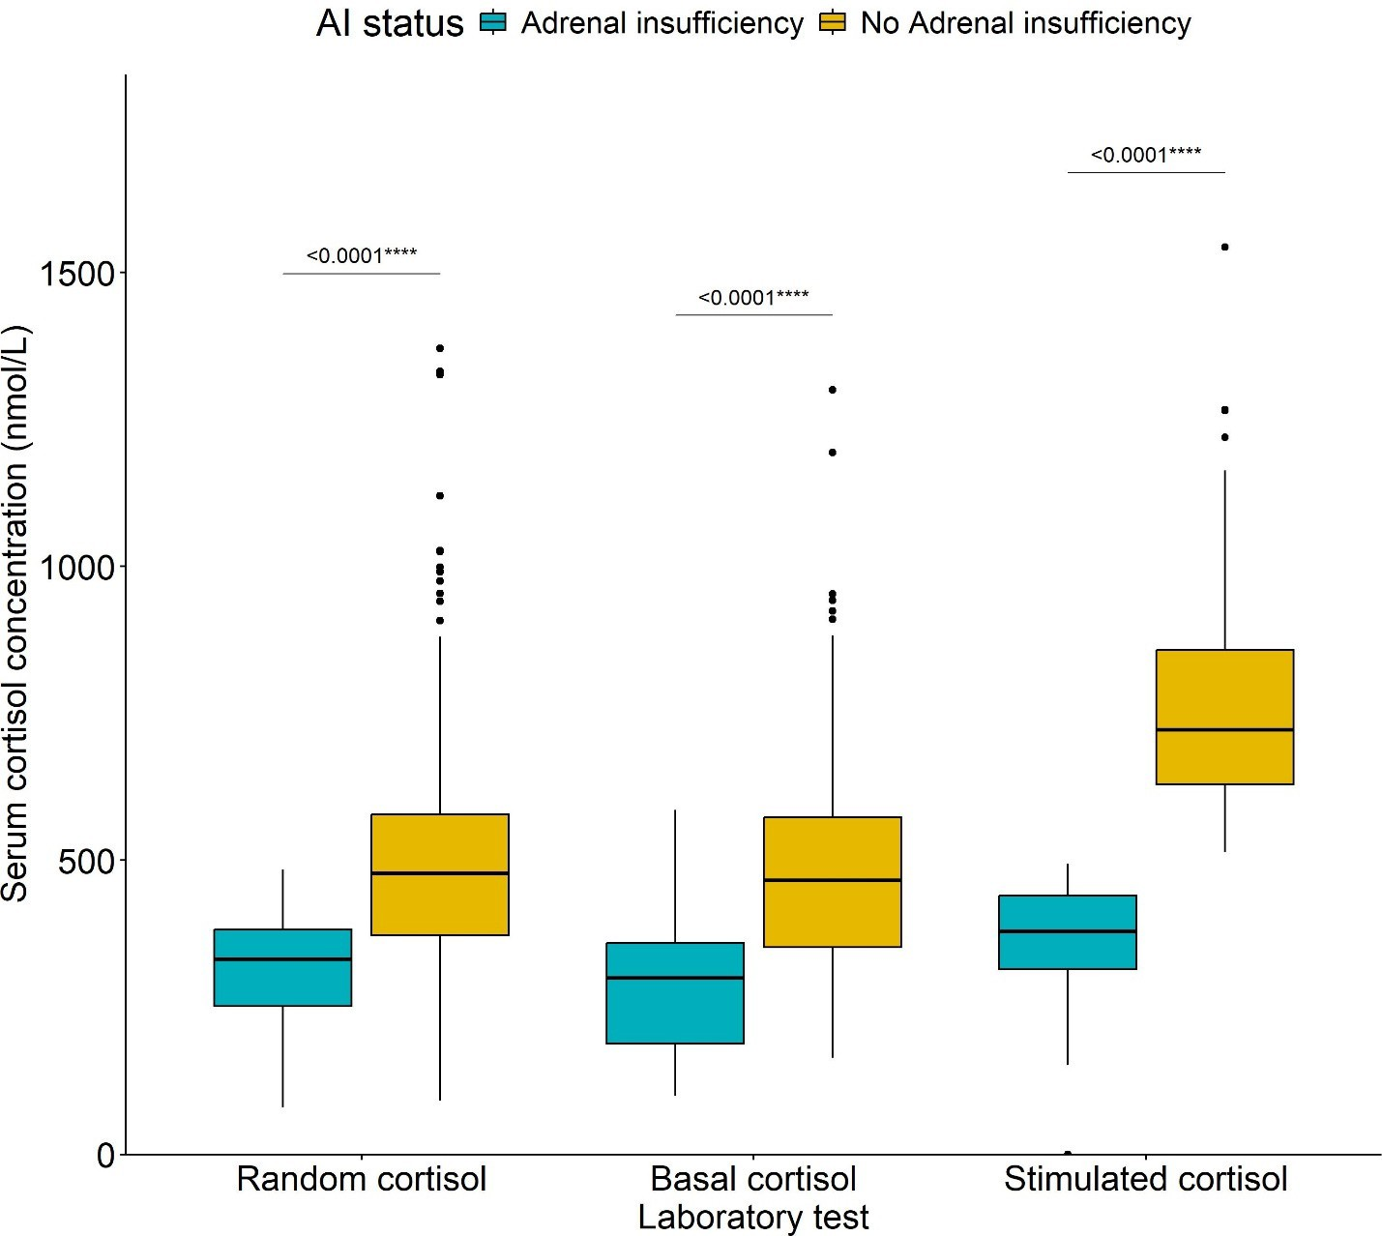

**Fig 2:** Cortisol concentrations in patients with adrenal insufficiency compared with those without adrenal insufficiency with **** representing *p*<0.001.

### Diagnosis of adrenal insufficiency

The differences between the patients with SAI versus those with PAI were duration of illness, which was longer in the SAI group,14 days (IQR:14.0-27.8) versus 10 days (IQR:7.0-14.0), *p*=0.006 and vomiting which occurred more often in the PAI group, compared with SAI 66.7% versus 20.8%, *p*=0.033, respectively.

**Table 2: Comparison of the demographics, history, clinical findings and biochemical findings between patients with SAI and those with PAI**

|  |  |  |  |
| --- | --- | --- | --- |
| Variable | PAI, *N* = 91 | SAI, *N* = 241 | p-value2 |
| **Age at enrolment, median (IQR) (years)** | 39.0 (31.0, 43.0) | 36.0 (33.0, 45.0) | >0.9 |
| **Female-gender, n(%)** | 4 (44.4%) | 12 (50.0%) | >0.9 |
| **Ethnicity, n(%)** |  |  | >0.9 |
| Black African | 8 (88.9%) | 20 (83.3%) |  |
| Other | 1 (11.1%) | 4 (16.7%) |  |
| **Duration of current illness, median (IQR) (days)** | 10.0 (7.0, 14.0) | 14.0 (14.0, 27.8) | **0.006** |
| **HISTORY** |  |  |  |
| **Weight loss** | 9 (100.0%) | 19 (79.2%) | 0.3 |
| **Weakness** | 6 (66.7%) | 21 (87.5%) | 0.3 |
| **Tiredness** | 7 (77.8%) | 22 (91.7%) | 0.3 |
| **Poor appetite** | 7 (77.8%) | 20 (83.3%) | >0.9 |
| **Increased skin pigmentation** | 4 (57.1%) | 9 (39.1%) | 0.7 |
| **Nausea** | 7 (77.8%) | 14 (58.3%) | 0.4 |
| **Vomiting** | 6 (66.7%) | 5 (20.8%) | **0.033** |
| **Liking for salt** | 5 (55.6%) | 15 (62.5%) | >0.9 |
| **Diarrhoea** | 2 (22.2%) | 10 (41.7%) | 0.4 |
| **Dizziness** | 5 (62.5%) | 13 (54.2%) | >0.9 |
| **Anorexia** | 6 (66.7%) | 8 (33.3%) | 0.12 |
| **Loss of axillary and pubic hair, if female** | 2 (22.2%) | 3 (12.5%) | 0.8 |
| **HAART exposure** | 2 (22.2%) | 6 (25.0%) | >0.9 |
| **CLINICAL FEATURES** |  |  |  |
| **BP (systolic) mmHg** | 120.0 (120.0, 127.0) | 116.0 (100.0, 129.5) | 0.4 |
| **BP (diastolic) mmHg** | 79.0 (70.0, 85.0) | 73.0 (61.5, 80.0) | 0.5 |
| **Any postural drop in blood pressure** | 0 (0.0%) | 3 (12.5%) | 0.5 |
| **Heart rate beats per minute** | 97.0 (84.0, 105.0) | 84.0 (76.5, 98.0) | 0.068 |
| **Hypotension** | 0 (0.0%) | 2 (8.3%) | >0.9 |
| **Presence of anaemia** | 6 (66.7%) | 13 (56.5%) | 0.7 |
| **INVESTIGATIONS** |  |  |  |
| **Viral load (log10 Copies/mL)** | 11.6 (11.6, 11.6) | 11.4 (10.9, 11.8) | >0.9 |
| **Random cortisol** | 281 (209.0,375.0) | 257.0 (236.5,369.0) | >0.9 |
| **Basal cortisol** | 315.0 (214.5,327.0) | 292.0 (190.3,371.3) | 0.9 |
| **Stimulated cortisol** | 403.0 (363.0,435.0) | 369.5 (312.5, 444.3) | 0.7 |
| **Delta cortisol** | 116.0 (24.5,133.5) | 107.0 (33.0,194) | 0.7 |
| **Tuberculosis** | 6 (66.7%) | 19 (79.2%) | 0.7 |
| ***Cryptococcus neoformans*** | 3 (33.3%) | 7 (29.2%) | >0.9 |
| **Pneumonia** | 1 (11.1%) | 3 (12.5%) | >0.9 |
| **Kaposis sarcoma** | 0 (0.0%) | 1 (4.2%) | >0.9 |
| **Herpes simplex virus (HSV)** | 0 (0.0%) | 1 (4.2%) | >0.9 |
| **Hepatitis B virus** | 0 (0.0%) | 3 (12.5%) | 0.5 |
| ***Candida albicans*** | 0 (0.0%) | 1 (4.2%) | >0.9 |
| **Total CD4 count** | 46.0 (23.0, 76.0) | 33.5 (12.5, 56.5) | 0.3 |
| **White cell count X109** | 5.2 (3.3, 6.5) | 5.3 (3.0, 11.0) | 0.6 |
| **Lymphocyte count X109** | 1.6 (1.4, 1.7) | 0.9 (0.5, 1.1) | 0.2 |
| **Neutrophils** | 3.2 (2.0, 4.3) | 1.6 (1.1, 2.5) | >0.9 |
| **Sodium mmol/L** | 133.0 (131.0, 135.0) | 135.0 (132.8, 137.0) | 0.2 |
| **Potassium mmol/L** | 3.7 (3.3, 5.4) | 4.0 (3.4, 4.6) | 0.9 |
| **Haemoglobin g/dL** | 10.2 (8.1, 10.4) | 8.7 (7.6, 10.7) | 0.6 |

HAART: Highly Active Antiretroviral Therapy

### Biochemistry: Comparison of cortisol concentrations in patients with AI and those without

The random cortisol was lower in the AI group, 332 nmol/L (252.0-382.0), compared with 478 nmol/L (372.5-578.0) in those patients without AI; (*p*<0.001). The basal cortisol was 300 nmol/L (188.5-359) in the AI group, compared with 466 nmol/L (352-573); (*p*<0.001) without AI. The stimulated cortisol was

379 nmol/L (314.5-440) in the AI group, compared with 722 nmol/L (630-858); (*p*<0.001) without AI (Figure 1).

The proportions of patients with a stimulated cortisol of 340 nmol/L, 400 nmol/L and 500 nmol/L, thus 12 patients would be diagnosed if the stimulated cut-off was 340 nmol/L, 18 patients would be diagnosed if a cut off of 400 nmol/L and 33 if 500 nmol/L was utilized.

**Comparison of clinical characteristics in patients with adrenal insufficiency with those without**

Extrapulmonary tuberculosis and cryptococcal infection occurred more often in the AI, compared with the remaining groups, whereas pulmonary tuberculosis occurred less often among patients diagnosed with AI. The diastolic blood pressure was higher in the AI, compared with the those without AI groups; *p*=0.012. There was greater use of fluconazole and opiates in the AI, compared with group without AI, 11 (33.3%) vs 63 (12.1%); *p*<0.002 and 12 (36.4%) vs 114 (21.9%); *p*=0.054, respectively. (Table 2)

**Table 3: Comparison of clinical characteristics in patients with adrenal insufficiency with those without**

|  |  |  |  |  |  |  |
| --- | --- | --- | --- | --- | --- | --- |
| ***Variable*** | | ***AI, N = 331*** | | ***Non-AI, N = 5211*** | | ***p- value2*** |
| Age at enrolment, median (IQR) (years) | | 39.0 (33.0, 44.0) | | 36.0 (31.0, 43.0) | | 0.4 |
| Female gender, N (%) | | 16 (48.5%) | | 266 (51.2%) | | 0.8 |
| Duration of current illness, median (IQR) (days) | | 14.0 (14.0, 21.0) | | 14.0 (11.8, 21.0) | | 0.7 |
|  | |  | |  | |  |
| **HISTORY** | |  | |  | |  |
| Weight loss | | 28 (84.8%) | | 429 (86.3%) | | 0.8 |
| Weakness | | 27 (81.8%) | | 421 (85.1%) | | 0.6 |
| Tiredness | | 29 (87.9%) | | 422 (85.1%) | | 0.8 |
| Poor appetite | | 27 (81.8%) | | 374 (76.0%) | | 0.4 |
| Increased pigmentation of the skin | | 13 (43.3%) | | 247 (50.9%) | | 0.4 |
| Nausea | | 21 (63.6%) | | 262 (52.9%) | | 0.2 |
| Vomiting | | 11 (33.3%) | | 137 (27.7%) | | 0.5 |
| Liking for salt | | 20 (60.6%) | | 264 (53.5%) | | 0.4 |
| Hypoglycaemia | | 0 (0.0%) | | 11 (2.2%) | | >0.9 |
| Loss of consciousness | | 0 (0.0%) | | 7 (1.4%) | | >0.9 |
| Diarrhoea | | 12 (36.4%) | | 220 (44.8%) | | 0.3 |
| Dizziness | | 18 (56.3%) | | 236 (47.9%) | | 0.4 |
| Shock | | 0 (0.0%) | | 5 (1.0%) | | >0.9 |
| Anorexia | 14 (42.4%) | | 233 (47.2%) | | 0.6 | |
| Loss of axillary and pubic hair, if female | 5 (15.2%) | | 95 (18.9%) | | 0.8 | |
|  | |  | |  | |  |
| **CLINICAL** | |  | |  | |  |
| BP (systolic) mmHg | | 120.0 (103.8, 129.3) | | 112.0 (102.0, 125.0) | | 0.2 |
| BP (diastolic) mmHg | | 73.0 (68.3, 80.8) | | 70.0 (60.0, 79.0) | | **0.012** |
| Heart rate beats per minute this | | 86.5 (77.0, 102.8) | | 91.0 (79.3, 109.0) | | 0.5 |
| Hypotension | | 2 (6.1%) | | 46 (9.3%) | | 0.8 |
| Any postural drop in blood pressure | 3 (9.1%) | | 20 (4.1%) | | 0.2 | |
| Presence of anaemia | 19 (59.4%) | | 291 (59.1%) | | >0.9 | |
|  |  | |  | |  | |
| **MANAGEMENT & OUTCOMES** |  | |  | |  | |
| Mortality | 7 (53.8%) | | 61 (43.9%) | | 0.5 | |
| Rifampicin | 1 (3.0%) | | 44 (8.4%) | | 0.5 | |
| Fluconazole | 11 (33.3%) | | 63 (12.1%) | | **0.002** | |
| Opiates | 12 (36.4%) | | 114 (21.9%) | | 0.054 | |
| HAART exposure | 8 (24.2%) | | 199 (38.2%) | | 0.11 | |
|  |  | |  | |  | |
| I**NVESTIGATIONS** |  | |  | |  | |
| Viral load (log10 copies/mL) | 11.6 (11.0, 11.9) | | 10.7 (7.0, 12.4) | | 0.6 | |
| Pulmonary tuberculosis | 14 (42.4%) | | 337 (64.7%) | | **0.01** | |
| Extrapulmonary tuberculosis | 11 (33.3%) | | 99 (19.0%) | | **0.045** | |
| *Cryptococcus neoformans* | 10 (30.3%) | | 20 (3.8%) | | **<0.001** | |
| Pneumonia | 4 (12.1%) | | 58 (11.1%) | | 0.8 | |
| Hepatitis B | 3 (9.1%) | | 15 (2.9%) | | 0.085 | |
| Candida albicans | 1 (3.0%) | | 34 (6.5%) | | 0.7 | |
| Kaposis sarcoma | 1 (3.0%) | | 5 (1.0%) | | 0.3 | |
| Herpes simplex virus | 1 (3.0%) | | 7 (1.3%) | | 0.4 | |
| Gastroenteritis | 0 (0.0%) | | 23 (4.4%) | | 0.4 | |
| Total CD4 count | 36.0 (15.0, 58.0) | | 34.0 (15.0, 63.0) | | >0.9 | |
| White cell count X109/L | 5.2 (3.0, 8.0) | | 5.6 (3.8, 8.2) | | 0.7 | |
| Lymphocyte count X109/L | 1.1 (0.6, 1.3) | | 0.8 (0.4, 2.0) | | 0.4 | |
| Neutrophils x109/L | 1.6 (1.0, 3.4) | | 3.7 (1.5, 9.0) | | 0.086 | |
| Sodium mmol/L | 135.0 (132.0, 137.0) | | 133.0 (130.0, 137.0) | | 0.14 | |
| Potassium mmol/L | 4.0 (3.3, 4.7) | | 4.1 (3.6, 4.6) | | 0.6 | |
| Haemoglobin g/dL | 9.5 (7.7, 10.6) | | 8.7 (7.4, 10.3) | | 0.2 | |

1Median (IQR); n (%); 2Wilcoxon rank sum test; Pearson's Chi-squared test; Fisher's exact test.

HAART: Highly Active Antiretroviral Therapy

**Table 4: Comparisons of the characteristics of patients who died without adrenal insufficiency versus those with AI**

The overall mortality at one-year follow-up was 11/33 (33.3%) among the AI group compared to the group without 140/521 (26.9%); (*p*=0.272). There was no significant difference in mortality at 3, 6 and 12 months for the two groups, respectively. There were, however, differences in the random cortisol, basal cortisol, stimulated cortisol, and incremental cortisol, with 509, (412, 636) versus 281, (12.3, 12.3); *p*=0.001, 483, (408, 608) versus 284, (201, 365); *p*<0.001, 768, (624, 9008) versus 375, (321, 426); *p*<0.001 and 260,(175, 356) versus 32, (17, 17); *p*<0.001, respectively, between the subgroups of deceased patients with AI versus patients without. As expected, higher cortisol concentrations were found in patients without AI. The mortality associated with *Cryptococcal neoformans* was however greater in the AI than in the non-AI groups, 45.5% vs 4.3%; *p*=0.008.

|  |  |  |  |  |
| --- | --- | --- | --- | --- |
| ***Table 4 : Characteristics of patients who died with and without AI*** | | | | |
| **Variable** | ***Non-AI, N = 1401*** | | ***AI, N = 111*** |  |
| Age at enrolment, median (IQR) (years) | 37 (32, 44) | | 41 (37, 48) | 0.2 |
| Female gender, n(%) | 75 (53.6%) | | 6 (54.5%) | >0.9 |
| Duration of current illness, median (IQR) (days) | 14 (14, 21) | | 14 (10, 14) | 0.13 |
| **HISTORY** |  | |  |  |
| Weight loss | 115 (89.1%) | | 9 (81.8%) | 0.6 |
| Weakness | 113 (87.6%) | | 9 (81.8%) | 0.6 |
| Tiredness | 114 (89.1%) | | 11 (100.0%) | 0.6 |
| Poor appetite | 106 (82.2%) | | 11 (100.0%) | 0.2 |
| Increased pigmentation of the skin | 76 (60.3%) | | 4 (44.4%) | 0.5 |
| Nausea | 77 (59.7%) | | 9 (81.8%) | 0.2 |
| Loss of consciousness | 4 (3.1%) | | 0 (0.0%) | >0.9 |
| Diarrhoea | 65 (50.4%) | | 3 (27.3%) | 0.14 |
| Dizziness | 67 (52.3%) | | 5 (45.5%) | 0.7 |
| Shock | 2 (1.6%) | | 0 (0.0%) | >0.9 |
| Anorexia | 67 (52.3%) | | 4 (36.4%) | 0.3 |
| Loss of axillary and pubic hair, if female | 33 (25.0%) | | 2 (18.2%) | 0.8 |
| **CLINICAL FEATURES** |  | |  |  |
| BP (systolic) | 110 (100, 123) | | 127 (114, 129) | 0.073 |
| BP (diastolic) | 70 (60, 80) | | 79 (67, 83) | 0.2 |
| Heart rate | 93 (80, 109) | | 82 (70, 103) | 0.2 |
| Hypotension | 16 (12.4%) | | 0 (0.0%) | 0.4 |
| Any postural drop in blood pressure | 7 (5.5%) | | 0 (0.0%) | >0.9 |
| Presence of anaemia | 81 (63.3%) | | 6 (54.5%) | 0.7 |
| **INVESTIGATIONS** |  | |  |  |
| Sodium mmol/L | 133.0 (129.0, | | 134.0 (132.0, | 0.12 |
|  | 137.0) | | 139.0) |  |
| Potassium mmol/L | 3.90 (3.50, 4.60) | | 3.90 (3.65, 4.65) | >0.9 |
| Haemoglobin g/dL | 8.40 (7.10, 9.60) | | 8.70 (7.45, 10.45) | 0.6 |
| Syphilis | 4 (2.9%) | | 0 (0.0%) | >0.9 |
| Candida | 7 (5.0%) | | 1 (9.1%) | 0.5 |
| Hepatitis B | 5 (3.6%) | | 1 (9.1%) | 0.4 |
| Herpes simplex virus HSV | 2 (1.4%) | | 0 (0.0%) | >0.9 |
| Pneumonia | 14 (10.0%) | | 0 (0.0%) | 0.6 |
| Pneumocystis Jiroveci Pneumonia | 2 (1.4%) | | 0 (0.0%) | >0.9 |
| Extrapulmonary tuberculosis | 26 (18.6%) | | 4 (36.4%) | 0.2 |
| Cryptococcus neoformans | 6 (4.3%) | | 5 (45.5%) | **<0.001** |
| Total CD4 count | 28 (12, 56) | | 43 (17, 67) | 0.3 |
| Viral load (log10 Copies/mL) | 10.3 (7.6, 12.7) | 12.3 (12.3, 12.3) | | 0.7 |
| Random cortisol | 509 (412, 636) | 281 (244, 341) | | **<0.001** |
| Basal cortisol | 483 (408, 608) | 284 (201, 365) | | **<0.001** |
| Stimulated cortisol | 768 (624, 908) | 375 (321, 426) | | **<0.001** |
| Incremental Cortisol | 260 (175, 356) | 32 (17, 107) | | **<0.001** |

1Median (IQR); n (%); 2Wilcoxon rank sum test; Pearson’s Chi-squared test; Wilcoxon rank sum exact test; Fisher’s exact test

### Predictors of mortality:

The increased odds of mortality were associated with skin pigmentation (62%), nausea (54%), poor appetite (81%) and liking of the salt (55%). With respect to the lab tests random cortisol, ACTH were associated with increased mortality risk, whereas opiates use and CD4 increase was protective against mortality.

The logistic regression analysis is seen in In Table 5. At, a 50 nmol/L increase in the basal cortisol was associated with a 11% increase in the odds of mortality (OR = 1.11, (95%CI:1.05, 1.18), *p*<0.001). Opiates were associated with a 44% reduction in the odds of mortality (OR = 0.56, (95%CI: 0.0.34, 0.90). Increased A 100 pg/L increase in the ACTH was associated with a 97% increase in the odds of mortality (OR = 1.97, (95%CI:1.15, 3.59); *p<*0.019).

**The multivariate analysis demonstrating factors independently predictive of mortality are shown in Table 5**.

After adjusting systolic BP, loss of consciousness, the only features which were associated with patient mortality were random cortisol and opiate use. Every 50 nmol/L increase in random cortisol was associated with 11% higher odds of mortality (aOR = 1.11 (95%CI:1.044, 1.172) *p*<0.001) after adjusting for opiates, systolic BP, loss of consciousness. While the use of opiates was associated with a 42% reduction in the odds of mortality (aOR = 0.58 (95%CI:0.35, 0.947), *p*=0.03) after adjusting for random cortisol, systolic BP, loss of consciousness.

### Table 5: Bivariate and Multivariate analysis of factors associated with time to mortality of patients in the entire cohort.

*Characteristic Bivariate multivariable*

|  |  |  |  |  |  |  |  |  |  |  |  |  |  |  |  |  |  |  |  |  |  |  |  |  |  |  |
| --- | --- | --- | --- | --- | --- | --- | --- | --- | --- | --- | --- | --- | --- | --- | --- | --- | --- | --- | --- | --- | --- | --- | --- | --- | --- | --- |
|  | **OR1** | | | | **95% CI2** | | | | ***p*-value** | | | | **aOR3** | | | | **95% CI2** | | | | ***p*-value** | | | | | |
|  |  | | | |  | | | |  | | | |  | | | |  | | | |  | | | | | |
| **History** | | |  | | | |  | | | |  | | | |  | | | | |  | | |  | | |
| Increased skin pigmentation | | | **1.62** | | | | **1.09, 2.41** | | | | **0.018** | | | |  | | | | |  | | |  | | |
| Poor_appetite | | | **1.81** | | | | **1.11, 3.04** | | | | **0.02** | | | |  | | | | |  | | |  | | |
| Liking_for_salt | | | **1.55** | | | | **1.05, 2.31** | | | | **0.03** | | | |  | | | | |  | | |  | | |
| Nausea | | | **1.54** | | | | **1.04, 2.30** | | | | **0.031** | | | |  | | | | |  | | |  | | |
| Loss of_consciousness | | | 3.71 | | | | 0.81, 19.0 | | | | 0.089 | | | | 3.49 | | | | | 0.73, 16.706 | | | 0.117 | | |
| BP (diastolic) (per 10 units) | | | 1.14 | | | | 0.99, 1.32 | | | | 0.074 | | | |  | | | | |  | | |  | | |
| BP (systolic) (per 10 units) | | | 0.91 | | | | 0.81, 1.01 | | | | 0.08 | | | | 0.9 | | | | | 0.802, 1.004 | | | 0.058 | | |
| **Investigations** | | |  | | | |  | | | |  | | | |  | | | | |  | | |  | | |
| Haemoglobin | | | 0.93 | | | | 0.85, 1.01 | | | | 0.093 | | | |  | | | | |  | | |  | | |
| GE_C_diff | | | 0.39 | | | | 0.09, 1.15 | | | | 0.13 | | | |  | | | | |  | | |  | | |
| Random cortisol (per 50U) | | | | **1.11** | | | | **1.05, 1.18** | | | | **<0.001** | | | | **1.11** | | **1.044, 1.172** | | | | | | **<0.001** | | | |
| ACTH (per 100 pg/ml) | | | | **1.97** | | | | **1.15, 3.59** | | | | **0.019** | | | |  | |  | | | | | |  | | | |
| CD4 (per 50 cell/µL) | | | **0.71** | | | | **0.51, 0.99** | | | | **0.048** | | | |  | | | | |  | | |  | | |
| **Medication** | | |  | | | |  | | | |  | | | |  | | | | |  | | |  | | |
| Opiates | | **0.56** | | | | **0.34, 0.90** | | | | **0.02** | | | | **0.58** | | | | | **0.35, 0.947** | | | **0.03** | | |
| Rifampicin | | | 1.53 | | | | 0.79, 2.87 | | | | 0.2 | | | |  | | | | |  | | |  | | |
| Fluconazole | | 1.65 | | | | 0.98, 2.74 | | | | 0.057 | | | |

1 Odds Ratio; 2 95% Confidence interval; 3 Adjusted Odds Ratio

## Preliminary discussion:

To our knowledge this is the largest study looking at the incidence of adrenal insufficiency and its mortality in patients with advanced HIV in Africa. Inspired by the knowledge that undiagnosed AI can be fatal in the event of complications, we sought to establish its presence and contribution to mortality in patients HIV and AIDS, with intention to mitigate this risk through early diagnosis and intervention. A 250 µg tetracosactide test was performed on 151 patients with random cortisol less than 500 nmol/L, using the Roche COBAS II ECLIA test. Using the 30 minute diagnostic cortisol concentrations cutoff’ of less than 500nmol/L., 27 patients were confirmed AI. Combined with 6 untested patients who were presumed AI on the basis of random cortisol and ACTH alone, the total number of patients with AI was 33. Further breakdown of this total showed majority SAI (24) and PAI (9). In view of possible overdiagnosis of AI using the 500 nmol/L cortisol cutoff, lower cortisol cutoffs of 400 nmol/L and 340 nmol/L yielded, 18 and 12 AI patients, respectively.

**The Major findings:**

1. Patients in the lower tertile were younger.
2. Overall, AI incidence in this cohort was 6.01% with a predominant SAI group.
3. The most common OI was PTB in Non-AI and Extra pulmonary tuberculosis and cryptococcus in the AI group.
4. Duration of illness was longer in the SAI versus PAI group. Sharma et al found that Duration of illness was predictive of AI in HIV patients.
5. Paradoxically, Sodium levels and Diastolic BP were higher in the AI versus the non-AI group.
6. Mortality was higher in the AI versus Non-AI group, though not significant.
7. The causes of death in 64% the AI group were pneumonia, cryptococcal meningitis, liver disease, chronic kidney disease, seizures and sepsis.
8. The rate of death began to increase after three months, and tuberculosis was the predominant cause of death in the non-AI group.
9. The overall mortality was 27.50%, with no significant difference in the AI versus non-AI groups, at 33.3% and 26.9%, respectively
10. The increased odds of mortality was associated with skin pigmentation, nausea, poor appetite and liking of the salt., random cortisol and ACTH, whereas opiates use and CD4 increase were protective against mortality.
11. The most common opportunistic infection was tuberculosis at (84%), followed by pneumonia (11.35%) and candida (6.2%).
12. Patients with adrenal insufficiency were associated with higher risk of extrapulmonary TB and cryptococcus neoformans, both of which are AIDS- defining illnesses and potential causes of AI.
13. The neutrophil counts were lower in the AI versus the non-AI group, though not significantly so.
14. There was significantly higher fluconazole, and opiate use in the AI group, both of which can reduce enzyme activity, leading to lower adrenal cortisol production.

AI associated Natural killer cell cytotoxicity (NKCC) dysfunction has been associated with

increased infections leading to increased mortality (19). The observed significant cryptococcal fungal infection in the adrenal insufficiency group may be explained by both numeric and functional decline in lymphocytes.

At multivariate analysis after adjusting for systolic BP, loss of consciousness, the only features which were associated with patient mortality were opiate use and elevated random cortisol. This finding is consistent with a study by Christ-Crain et al (20) in which elevated cortisol levels were associated with poor outcomes in AI patients with community acquired pneumonia (CAP) in ICU.

### Strengths and Weaknesses:

### This is the biggest study on adrenal insufficiency in HIV positive patients in Africa.

### The weaknesses

### A small AI sample size.

### It is a single center study and may thus its findings may not be generalizable.

### Unavailability of the LC/MS which is the new GOLD Standard for steroid analysis.

**Conclusion:**

The largest African study on hypoadrenalism in advanced HIV revealed the AI incidence of 6.01% and overall mortality of 27.50%. We feel that screening for AI is warranted in advanced HIV, to mitigate the risk of death. The majority of the opportunistic infections were tuberculosis, pneumonia and cryptococcal infection. Tuberculosis and cryptococcal infections invariably correlated with the aetiology of mortality and may be AI-defining illnesses in advanced HIV, while elevated cortisol was associated with increased odds of death. Early AI detection, appropriate treatment, sick-day treatment adjustments education and shorter initial follow up intervals of HIV positive patients with AI is advised to prevent post discharge death

### Uncategorized References

1. Dunlop D. Eight-six cases of Addison's disease. British medical journal. 1963;2(5362):887.
2. Betterle C, Morlin L. Autoimmune Addison’s disease. Pediatric adrenal diseases. 2011;20:161-72.
3. Ross IL, Levitt NS. Addison’s disease symptoms–a cross sectional study in urban South Africa. PLoS One. 2013;8(1):e53526.
4. Mofokeng TR, Beshyah SA, Mahomed F, Ndlovu KC, Ross IL. Significant barriers to diagnosis and management of adrenal insufficiency in Africa. Endocrine connections. 2020;9(5):445- 56.
5. Mofokeng TRP, Ndlovu KCZ, Beshyah SA, Ross IL. Tiered healthcare in South Africa exposes deficiencies in management and more patients with infectious etiology of primary adrenal insufficiency. Plos one. 2020;15(11):e0241845.
6. Goliber T. The status of the HIV/AIDS epidemic in Sub-Saharan Africa. Population Reference Bureau. 2002.
7. Hofbauer LC, Heufelder AE. Endocrine implications of human immunodeficiency virus infection. Medicine. 1996;75(5):262-78.
8. Boulle A, Schomaker M, May MT, Hogg RS, Shepherd BE, Monge S, et al. Mortality in patients with HIV-1 infection starting antiretroviral therapy in South Africa, Europe, or North America: a collaborative analysis of prospective studies. PLoS medicine. 2014;11(9):e1001718.
9. Arlt W. Adrenal insufficiency. Clinical medicine. 2008;8(2):211.
10. Husebye ES, Pearce SH, Krone NP, Kämpe O. Adrenal insufficiency. The Lancet. 2021;397(10274):613-29.
11. Eledrisi MS, Verghese AC. Adrenal insufficiency in HIV infection: a review and recommendations. The American journal of the medical sciences. 2001;321(2):137-44.
12. Bornstein SR. Predisposing factors for adrenal insufficiency. New England Journal of Medicine. 2009;360(22):2328-39.
13. Afreen B, Khan KA, Riaz A. Adrenal insufficiency in Pakistani HIV infected patients. Journal of Ayub Medical College Abbottabad. 2017;29(3):428-31.
14. Odeniyi I, Fasanmade O, Ajala M, Ohwovoriole A. Adrenocortical function in Nigerians with human immunodeficiency virus infection. Ghana Medical Journal. 2013;47(4):171.
15. Bergthorsdottir R, Leonsson-Zachrisson M, Odén A, Johannsson G. Premature mortality in patients with Addison’s disease: a population-based study. The Journal of Clinical Endocrinology & Metabolism. 2006;91(12):4849-53.
16. Johannsson G, Falorni A, Skrtic S, Lennernäs H, Quinkler M, Monson JP, et al. Adrenal insufficiency: review of clinical outcomes with current glucocorticoid replacement therapy. Clinical endocrinology. 2015;82(1):2-11.
17. Vogeser M, Kratzsch J, Ju Bae Y, Bruegel M, Ceglarek U, Fiers T, et al. Multicenter performance evaluation of a second generation cortisol assay. Clinical Chemistry and Laboratory Medicine (CCLM). 2017;55(6):826-35.
18. Holst JP, Soldin SJ, Tractenberg RE, Guo T, Kundra P, Verbalis JG, et al. Use of steroid profiles in determining the cause of adrenal insufficiency. Steroids. 2007;72(1):71-84.
19. Bancos I, Hazeldine J, Chortis V, Hampson P, Taylor AE, Lord JM, et al. Primary adrenal insufficiency is associated with impaired natural killer cell function: a potential link to increased mortality. European journal of endocrinology. 2017;176(4):471-80.
20. Christ-Crain M, Stolz D, Jutla S, Couppis O, Müller C, Bingisser R, et al. Free and total cortisol levels as predictors of severity and outcome in community-acquired pneumonia. American journal of respiratory and critical care medicine. 2007;176(9):913-20.

A total of 550 patients were included in this study, although not all features were recorded for every individual. Among these patients, 43 were identified as having probable adrenal insufficiency. The dataset was divided into training and testing subsets, as summarized in Table 2.

Table 1 lists the features considered for predicting the presence of adrenal insufficiency. It should be noted that, although the current dataset is insufficient to draw definitive conclusions, it is still adequate to illustrate certain trends and guide future investigations into early prediction of adrenal insufficiency.

Because it is unclear which features are most predictive, a primary objective was to identify the feature subsets yielding the most accurate models. Consequently, various machine learning models were trained and evaluated on every possible combination of features.

Initially, logistic regression was employed, but it produced relatively poor performance across all feature sets. This suboptimal outcome may stem from the limited sample size or the inherent characteristics of the data, which may not align well with the logistic regression framework.

Subsequently, a small fully connected neural network (FNN) was explored. The network design comprised two hidden layers with 16 and 8 units, respectively, each followed by a rectified linear unit (ReLU) activation, and a final output layer applying a sigmoid function to generate probability estimates. Experiments with larger networks indicated poorer performance, suggesting that smaller models are more effective given the limited data. Each model was again trained on every combination of features to determine which variables contribute most strongly to predicting adrenal insufficiency.

The best-performing neural network achieved a training sensitivity of 1.00, a training specificity of 0.95, a testing sensitivity of 0.80, and a testing specificity of 0.94 (see Table 3). The features used for this model were: Nausea, Liking for Salt, Random Cortisol Result, ACTH Result, Neutrophils, Sodium, Current Tuberculosis, Diarrhea, Weight Loss, and Total CD4 Count. Figure 1 presents the ROC curve for the test set, with an AUC of 0.950, illustrating strong predictive performance. Figure 2 provides insights into feature importance, highlighting that Sodium and Random Cortisol Results exhibit particularly strong influence on the model’s predictions.

Table 4 provides details for the top 100 of the trained models, specifying which features they employed and the frequency with which each feature appeared. This frequency analysis, generated using integrated gradients to estimate feature importance, further underscores the critical roles of Sodium and Random Cortisol Results in predicting adrenal insufficiency.

|  |
| --- |
| **Features** |
| Nausea |
| Vomiting |
| Dizziness |
| Liking for salt |
| BP (diastolic) |
| Random cortisol result |
| ACTH result |
| Neutrophils |
| Sodium |
| Current tuberculosis |
| Potassium |
| Lymphocyte count |
| Diarrhoea |
| Weight loss |
| Total CD4 count |
| Ethnicity |
| Increased pigmentation of the skin |
| Any postural drop in blood pressure |

**Table 1: Features Considered in the Analysis**

|  |  |  |
| --- | --- | --- |
| **Dataset** | **Patients with Adrenal Insufficiency** | **Patients without Adrenal Insufficiency** |
| **Training** | 33 | 453 |
| **Testing** | 10 | 54 |

**Table 2: Dataset Partitioning**

|  |  |  |
| --- | --- | --- |
| **Performance Metric** | **Train Dataset** | **Test Dataset** |
| **Accuracy** | 0.953 | 0.922 |
| **Sensitivity** | 1.000 | 0.800 |
| **Specificity** | 0.949 | 0.944 |
| **Precision** | 0.589 | 0.727 |
| **Recall** | 1.000 | 0.800 |
| **F1 Score** | 0.742 | 0.762 |
| **ROC AUC Score** | 0.994 | 0.950 |

**Table 3: Performance Metrics of the Best Neural Network**

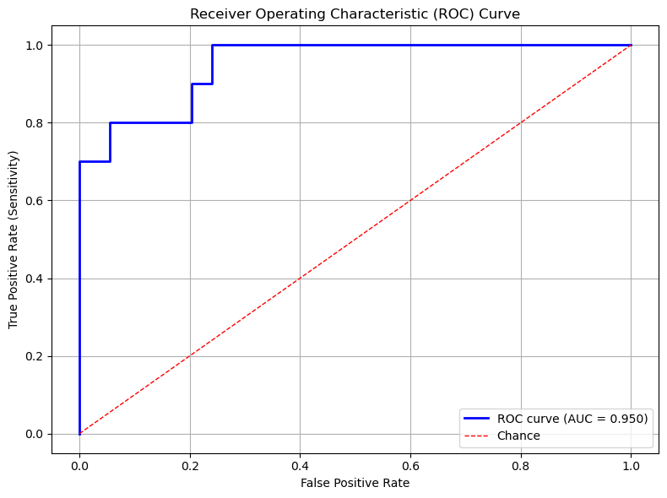**Figure 1: ROC Curve for the Testing Data (AUC = 0.950)**

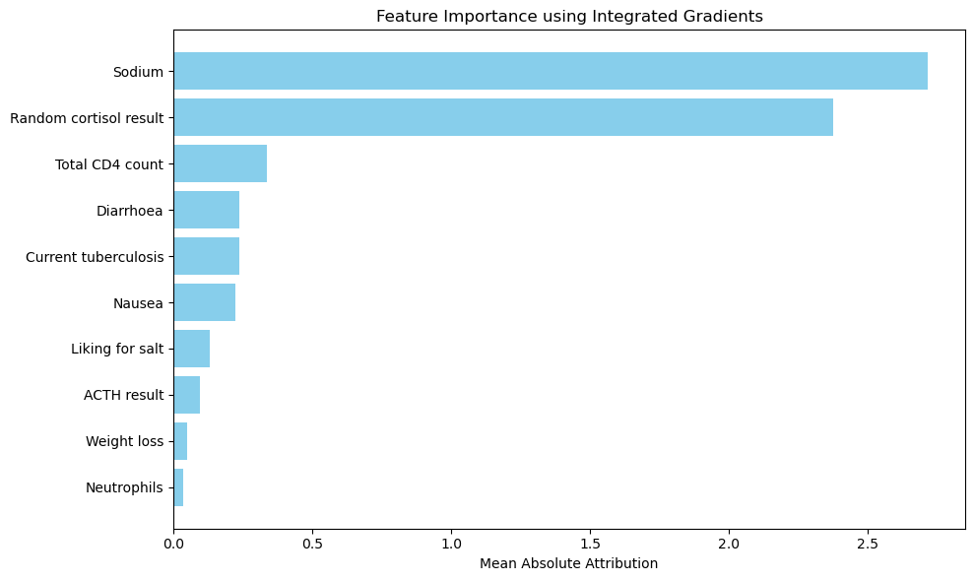

**Figure 2: Feature Importances According to the Best Neural Network Model**

|  |  |
| --- | --- |
| **Feature** | **Frequency** |
| Random cortisol result | 99 |
| Sodium | 99 |
| Dizziness | 60 |
| Weight loss | 56 |
| Liking for salt | 53 |
| Increased pigmentation of the skin | 51 |
| Neutrophils | 50 |
| ACTH result | 49 |
| Ethnicity | 48 |
| Nausea | 47 |
| Diarrhoea | 46 |
| Potassium | 44 |
| Vomiting | 43 |
| Any postural drop in blood pressure | 43 |
| Current tuberculosis | 38 |
| Lymphocyte count | 35 |
| Total CD4 count | 27 |
| BP (diastolic) | 25 |

**Table 4: Feature Frequency in Top 100 Models**